EXAMPLE RESEARCH BRIEF

FRAMING THE PROBLEM
Sex work is primarily viewed as:
- Sexuality rights issue
- Human rights issue

Presenting different narratives regarding the problem with current prostitution policy, the most convincing arguments framed it as an issue of crime victimization and public health.

Crime Victimization Frame
- Criminalizing prostitution make sex workers more likely to experience sexual and physical violence.
- Criminalization makes them more vulnerable to theft, rape, and assault by bad actors because they can’t rely on protections from the law.

Public Health Frame
- Criminalizing prostitution represent a significant threat to the health of individuals and communities.
- Criminalization increases the risk of unsafe sex practices because police can confiscate condoms as evidence.
- Sex workers often can’t access healthcare because of the risk of being arrested, or due to discrimination and mistreatment by medical staff.

CRIMINALIZATION IS NOT THE SOLUTION
Over 50% of Americans believe people should receive social services, like medical and housing assistance, child support, and educational and vocational training, instead of jail time for prostitution offenses.

Over 50% of Americans do not believe criminalization keeps sex workers safe.

Over 78% of Americans support sex workers’ criminal immunity when reporting crimes.

SUPPORT FOR HARM REDUCTION

When asked about the ideal goal of prostitution policy, the most popular response was harm reduction.
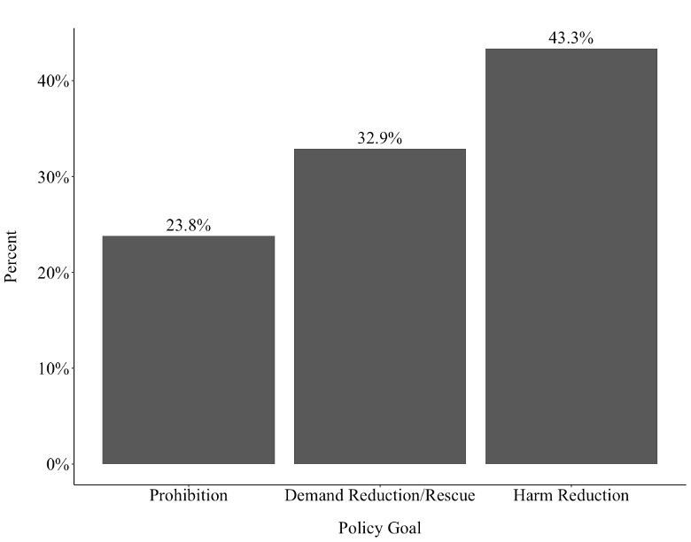

These findings overall suggest the American public supports a more humane policy response to sex work than criminalization.

